STATUE
Pasar de Suite Bundler: http://www.statue.com/Products/Cherubs/Smiling-Cherub-Piped-Water-Feature-Statue.html a Suite Commerce: http://staging.statue.com/Smiling-Cherub-Piped-Water-Feature-Statue

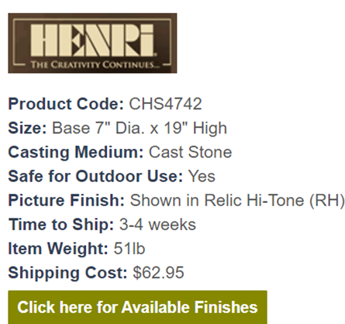

The Click Here for available finishes generates a page overlay showing the different finishes shown. I do not have the chops to write that HTML code, and he expects us to do it for him as I guess we did it before.
I am unable to locate where that code currently exists within NS, so I cant steal it from there. I was able to confirm that if we create a RT custom field it can host the HTML, but someone would need to either locate or write that HTML. Is this something you are skilled enough to create or will this need to go to Dev? Si, en el template con
I did have a note on this field from KT, but it simply noted that this existed but additional work here wouldn’t be needed because client was going matrix.

When looking at the page, the following is all the code I can see:
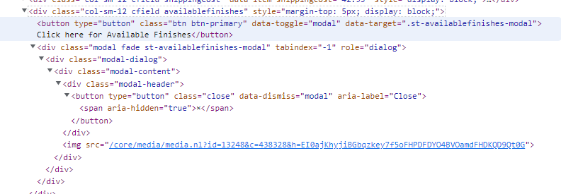
<div class="col-sm-12 cfield availablefinishes" style="margin-top: 5px; display: block;">
<button type="button" class="btn btn-primary" data-toggle="modal" data-target=".st-availablefinishes-modal">Click here for Available Finishes</button>
<div class="modal fade st-availablefinishes-modal" tabindex="-1" role="dialog">
<div class="modal-dialog">
<div class="modal-content">
<div class="modal-header">
<button type="button" class="close" data-dismiss="modal" aria-label="Close"><span aria-hidden="true">×</span></button>
</div>
<img src="/core/media/media.nl?id=13248&amp;c=438328&amp;h=EI0ajKhyjiBGbqzkey7f5oFHPDFDYO4BVOamdFHDKQD9Qt0G">
</div>
</div>
</div>
</div>
The Henri image above is another image field stored within the product, do you know how to get that image to come through via Custom Fields?

Code on site is
Finally, below the Available finish button is another field, that is currently hidden. This field displays a please call for shipping price image. I have tried to direct him to use a text field for this, but he wants to display the logo. The image should be pulled from Image For Free Shipping, which on the product below (http://www.statue.com/Products/Pedestals-Columns-Plinths-Pillars-23-and-under/Classical-Fluted-Plinth-Pedestal-16-H.html) is a blank / white box, code below the image.
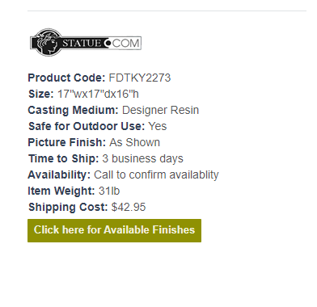
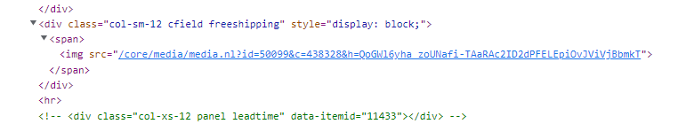
These are the additional changes/clarifications Josh is looking for us to provide/give feedback on. He is also asking on the text fields called out, I was able to provide him with the text fields from the item record, for the check box and list fields I have directed him to Support to provide the logic on what to call out.
Can I get someone from Dev assigned to J869106 as I need some assistance in scoping out a few customizations to bring our PDP page inline with the clients current SB page. Once the Dev gets assigned I will add them to this thread and bring them up to speed with any changes between now and then.
The only thing to add is the following wich the client confirmed last night:

When it comes to the Shipping image, what logic is the site supposed to be using? Is it simply the presence of an image stored here 
? Or is there additional logic?

For Logo image, the logic is again as simple as if we have an image linked 
, that we display it on the PDP page like it is now on SB.

This is correct for both cases, if there is no image present, nothing displays. If we have an image, then it shows up. There is nothing further driving this that I am aware of.

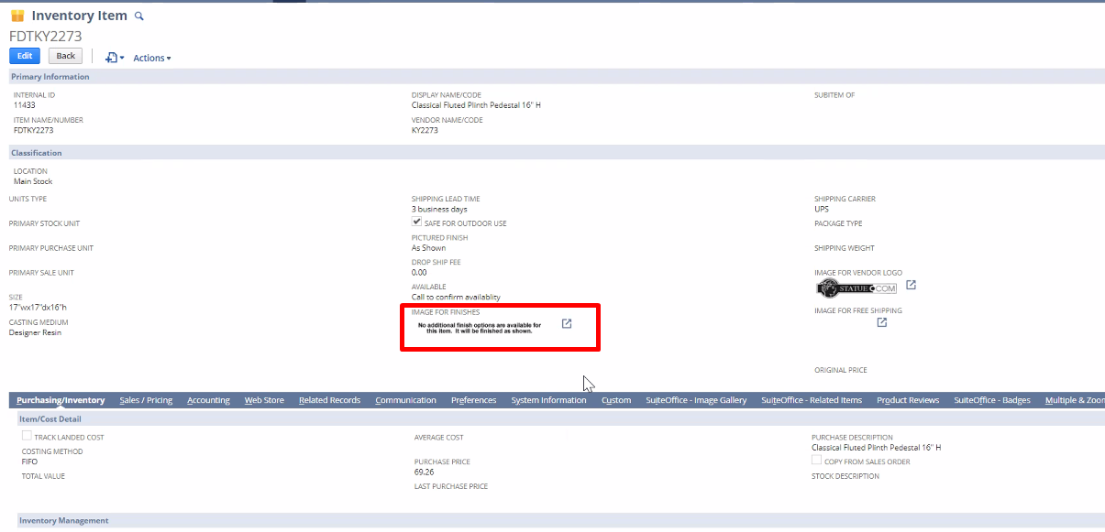El pop up carga la imagen que esta en image for finishes

Y también las dos imágenes:
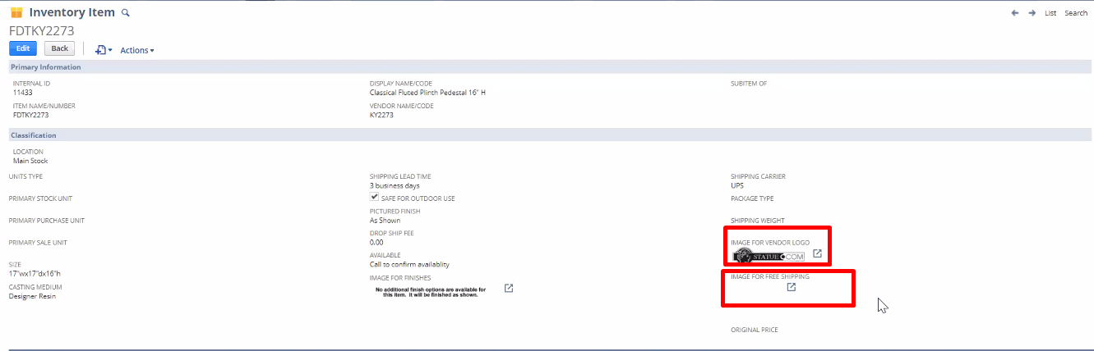
Estas se cargan siempre
Sitios de prueba:
http://www.statue.com/Products/Cherubs/Smiling-Cherub-Piped-Water-Feature-Statue.html
http://staging.statue.com/Smiling-Cherub-Piped-Water-Feature-Statue

